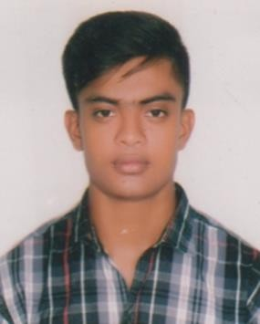

CURRICULAM

VITAE

**Md. Limon Mia**

Address : Parkmor, Ashratpur, Rangpur. Primary Mobile No: 01612025698

**E-Mail:** [eco12003037brur@gmail.com](mailto:eco12003037brur@gmail.com)

**Career Objective**

Seeking a challenging position in a reputed organization where I can learn new skills, expand my knowledge, and leverage my learnings.

**Academic Qualifications**



# Department of Economics (B.S.S)

**Institution :** Begum Rokeya University, Rangpur

**Department :** Economics

**Passing Year :** Running

# Higher Secondary Certificate (H.S.C)

**Institution :** Gaibandha Govt. College.

**Board :** Dinajpur Board

**Group : Arts**

**Year :** 2019

**Result :** GPA- 4.67 (Out of 5.00)

|  |  |  |  |
| --- | --- | --- | --- |
| **Secondary** | **School** | **Certificate (S.S.C)** |  |
| **Institution** | **:** | KAMARJANI MERCHANTS' HIGH SCHOOL |
| **Board** | **:** | Dinajpur Board |
| **Group** | **:** | **Science** |  |
| **Year** | **:** | 2017 |  |
| **Result** | **:** | GPA- 4.95 (Out of 5.00) |  |



**Computer Skill**

* Computer Office Program: MS. Word, MS. Power Point.
* Internet, Browsing.

**Personal Details**



# Certificate Name : Md. Limon Mia

 Fathers’s Name : Md. Abdul Kuddus Mia

 Mother’s Name : Mst. Najma Begum

Permanent Address : Karaibar, Kamarjani, Gaibandha Sadar, Gaibandha. Present Address : Parkmor, Ashratpur, Rangpur

 Date of Birth : 8 March, 2001

 Nationality : Bangladeshi (By birth)

 Religion : Islam

 Sex : Male

 Blood Group : O (+ve)

 Marital Status : Unmarried

 Height : 5 Feet 5 Inch

 National ID No : 2860936299

**Language Proficiency**

 Bengali

 English

**INTERESTS**

 Reading, Writing, Magazine and Book.



(**Md. Limon Mia)**